**Name: ___________________________________ Math 127 – Test 2D – Fall 2015**

**Oath: “*I will not discuss the exam contents with anyone until it is returned to me by my instructor*”.**

**Sign Name: _____________________________________________________**

**The penalty for cheating on this exam is a grade of 0% for Math 127 Exam 2.**

**Testing Center Staff Instructions**

**1. One sheet of handwritten or typed notes is OK.**

**Students may not use the “pink sheet” or any copied or scanned answer keys or Math 127 department documents.**

**2. Collect the sheet of notes and staple it to the test when submitted.**

**3. Any calculator is OK. No cell phone calculators.**

**4.** [**www.statcrunch.com**](http://www.statcrunch.com) **is required. All other webpages are prohibited.**

**5. Test must be completed in one sitting, but it is untimed. Very short bathroom breaks are permitted.**

**Student Instructions**

**1.** This test is graded out of 100 points and counts for 20% of your Math 127 grade.

**2.** Show work when necessary or points will be deducted. If you only report an answer and it is wrong, you will receive no credit. You may use the StatCrunch calculators for any probability calculations when appropriate.

**3.** Points are in parentheses for each question.

**4.** Good luck, do your best.

**1.** We have an **Exponential** model with a mean of 17.

**1a. (2)** Give P(*X* is at most 1) = ____________________. Draw and label below. **(1)**

**1b. (2)** Give the 57th percentile: ___________________. Draw and label below. **(1)**

**2.** We have a **Binomial** model with *n* = 12 and *p* = 0.20.

**2a. (2)** Give P(at least 2 successes) = _____________________.

**2b.** **Extra Credit (2 points).** Give the closest approximation to the 80th percentile: ___________________

**3.** We have a **Normal** model with *μ* = 60 and *σ* = 50.

**3a. (2)** Give P(*X* is between –50 and +50) = __________________. Draw and label below. **(1)**

**3b. (2)** Give 5th percentile: ________________. Draw and label below. **(1)**

**4.** We have a **Uniform** model on the interval [10, 25].

**4a. (2)** Give P(X > 20) = ______________________. Draw and label below. **(1)**

**4b. (2)** Give the 25th percentile: _______________________ Draw and label below. **(1)**

**5.** An actuary for an insurance company created the following probability table for a certain home insurance policy for a home in Minneapolis, MN.

|  |  |  |
| --- | --- | --- |
| **Event** | **Payout to Policy Holder** | **Probability** |
| **No claim** | **$0** | **0.9218** |
| **Minor claim** | **$5000** | **0.0644** |
| **Medium claim** | **$25,000** | **0.0092** |
| **Major Claim** | **$400,000** | **0.0046** |

**5a. (2)** Presuming years are independent, determine the probability that over the course of 30 years, the policy holder is paid some money at least once. Show calculation.

**5b. (2)** Determine the expected payout each year. Show calculation.

**5c. (2)** Show calculation. P(Medium claim two years in a row) =

**6a. (2) New problem.** Draw the Venn diagram and label everything properly. On 80% of days, Professor Kupe plays piano. On 15% of days he rides his mountain bike. On 10% of days, he does both.

**6b. (2)** What’s the probability on a random day he does neither activity? ____________________

**7.** Use the Venn Diagram to answer questions **7a – 7c**.

All Cecil College Calculus Students Since College Opened in 1968

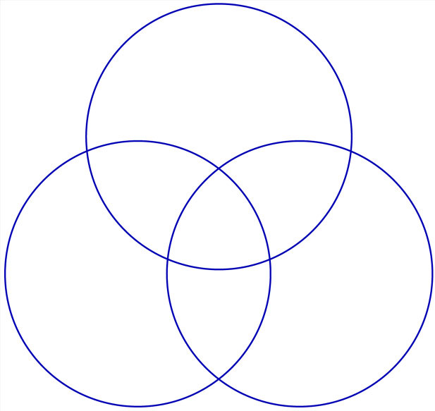

Have Taken Calc I at Cecil

0.40

0.05

0.15

0.15

0.00

0.02

0.00

0.23

Have Taken

Calc III

at Cecil

Have Taken Calc II

at Cecil

**7a. (2)** Determine the probability that three random calc students have all taken Calc II at Cecil. Show calculation.

**7b. (2)** Determine the probability that a calc student has taken Calc II and Calc III .

**7c. (2)** P(Calc II | Calc I) =

**8. (2)** ***Midnight White*** paint has blue dye added to it by the Home Depot associate. The amount of blue dye follows a N(5 ml, 0.03 ml) model.

You buy 10 cans to paint your solarium. What’s the probability that all 10 cans fall within two standard deviations of the mean of 5 ml of blue? Show calculation.

**9.** For a typical Math 127 class with *n* = 30 students, suppose each student has a *p* = 0.95 probability of attending on any random day.

**9a. (2)** P(Perfect attendance) = ______________________

**9b. (2)** P(At least 28 students show up) = ______________________

**9c. (2)** Explain why it is inappropriate to use the Normal approximation for the Binomial model for this problem:

_________________________________________________________________________________________

_________________________________________________________________________________________

_________________________________________________________________________________________

**10.** We will program a computer to spit out completely random numbers on the real number line from –10 to +90. Since all real numbers are equally likely, a Uniform model is appropriate.

**10a. (2)** Draw the model, label entirely, and give the probability function *f*(*x*) = ______________________________.

**10b. (2)** Determine the P(computer spits out a negative number) = ____________________________________

**10c. (2)** Calculate the mean for this probability model. Show calculation.

**11. (2)** We will model IQ scores for Harvard students with a Normal model. We will assume the standard deviation is 15 but don’t know the mean. From some actual IQ tests we found, it is learned that 3% of the test takers had an IQ score of 137 or above. Determine the mean IQ score at Harvard. Show calculation.

**12. (2)** A jogger feels confident he averages 20 miles each week but hasn’t a clue on the standard deviation for his miles. He checks his records and determines that for 10% of the weeks, he jogged 15 miles or less. Assuming a Normal model applies, calculate his standard deviation for mileage. Show calculation.

**13.** Use the contingency table generated from our “**Calendar Year 2015 Large Survey**” to answer question **13**.

**Contingency table results:** Rows: Instagram Columns: Facebook

|  |  |  |  |  |  |
| --- | --- | --- | --- | --- | --- |
|  | All the time | Never | Rarely | Sometimes | Total |
| All the time | 17.82% | 5.14% | 6.65% | 8.76% | 38.37% |
| Never | 7.85% | 10.27% | 7.55% | 6.34% | 32.02% |
| Rarely | 3.63% | 1.21% | 0.91% | 3.32% | 9.06% |
| Sometimes | 5.44% | 3.63% | 3.93% | 7.55% | 20.54% |
| Total | 34.74% | 20.24% | 19.03% | 25.98% | 100% |

**13a. (2)** P(Rarely Use Instagram | Rarely Use Facebook) = ________________________________________

**13b. (2)**  P(Three random students all use Facebook all the time) = ____________________________________

**14.** The big regression problem. Use the “**ZZZ Retired -** **Calendar Year 2015 Grocery Prices**” dataset. We will be predicting the “***Supermarket Price***” based on *x* = “***Wal-Mart Price***”.

**14a.** First things first. Check the scatterplot. The 2 Liter of Coker and the Snickers bar have to come out, clearly those were typos. Remove them for this entire problem. Once they’re out, you should have *n* = 124 data points with a mean “***Wal-Mart Price***” of $3.34 and a mean “***Supermarket Price***” of $3.94.

**14b.** Pretend we work for Food Lion, **so all we care about are the Food Lion data points**. There are 40 of them left after removing the Coker and the Snickers.

**14c.** Create your scatterplot **for Food Lion only**, using the Where Box, Where Supermarket = “***Food Lion***”.

**14d.** Run your linear regression **for Food Lion only**, using the Where Box, Where Supermarket = “***Food Lion***”. Save your residuals, Studentized residuals, and Cook’s. If you did this correctly, the *y*-intercept should be 0.73264531.

Alright, answer the following questions. **Everything is for Food Lion data only**!

**14e. (3)** Form: _________________ Direction: _________________ Measure of Strength: ____________

**14f. (4)** Interpret the slope with a sentence in the context of the problem. Include all units.

_________________________________________________________________________________________

_________________________________________________________________________________________

_________________________________________________________________________________________

**14g. (4)** Why is the *y*-intercept of $0.73 not an interpretable value? There are two reasons. Give them both.

1. _______________________________________________________________________________________

2. _______________________________________________________________________________________

**14h. (4)** A product for $3.39 at Wal-Mart is predicted to cost $______________ at Food Lion.

**14i. (4)** “***Naked Mighty Mango***” has a residual of –$0.75. Interpret the residual with a sentence in context.

_________________________________________________________________________________________

_________________________________________________________________________________________

_________________________________________________________________________________________

**14j. (4)** Interpret the value of *se*with a sentence in the context of the problem:

_________________________________________________________________________________________

_________________________________________________________________________________________

_________________________________________________________________________________________

**14k. (4)** Interpret the value of *R*2 with a sentence in the context of the problem:

_________________________________________________________________________________________

_________________________________________________________________________________________

_________________________________________________________________________________________

**14l. (3)** Only one product has an unusually large positive or negative Studentized residual.

Which product? _____________________________________________________

Actual residual: ________________________

Studentized residual: ________________________

**14m. (4)** Two products have unusually large Cook’s distances:

Product 1: ____________________________________________ Cook’s: ______________

Product 2: ____________________________________________ Cook’s: ______________

**14n. (4)** The Cheerios in row 19 have a residual of $0.43. Verify below the calculation to arrive at this residual.

**14o. (4)** Give a range of *x* = “***Wal-Mart Prices***” for which you would be comfortable using the equation for prediction.

Minimum Wal-Mart price: __________________ Maximum Wal-Mart Price: ___________________